**SQL Homework – 03** Fani Shundovska

1.

Zadaca 3 - prasanje 1

--We need **to** **count** **all** Companies aggregated **by** Country which meets the **following** conditions, sorted **by** Country:

⦁ There **is** **data** **for** Region;

⦁ Can be contacted **by** Fax;

⦁ The ID **of** Customer **starts** **with** ‘A’, ‘B’ **or** ‘CA’;

⦁ The Country **is** **not** **one** **of** Germany, Argentina **or** Spain **and** does **not** **starts** **with** ‘U’ **and** has 3 letters;

- WITH RESULT

**SELECT** Country,**COUNT**(CompanyName) **AS** Company

**FROM** customers

**WHERE** Region **IS** **NOT** **NULL** **AND** Fax **IS** **NOT** **NULL** **AND** CustomerID **LIKE** 'a%' **OR** CustomerID **LIKE** 'b%' **OR** CustomerID **LIKE** 'ca%'

**GROUP** **BY** Country

**HAVING** Country **NOT** **IN** ('Argentina','Germany','Spain') **and** Country **NOT** **LIKE** 'U_%'

**ORDER** **BY** Company;

- WITHOUT RESULT

**SELECT** Country, **COUNT**(*) **AS** CompanyCount

**FROM** customers

**WHERE** Region **IS** **NOT** **NULL**

**AND** Fax **IS** **NOT** **NULL**

**AND** (CustomerID **LIKE** 'A%' **OR** CustomerID **LIKE** 'B%' **OR** CustomerID **LIKE** 'CA%')

**AND** Country **NOT** **IN** ('Germany', 'Argentina', 'Spain')

**AND** Country **NOT** **LIKE** 'U%'

**AND** **LENGTH**(Country) = 3

**GROUP** **BY** Country

**ORDER** **BY** Country;

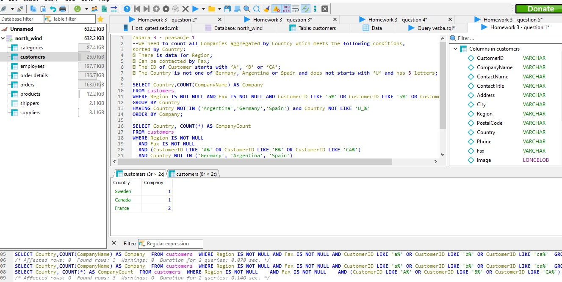

Zadaca 3 - prasanje 2

--We need **data** **for** ID **of** Supplier, **Name** **of** Company, **Name** **of** Contact,

Address **and** City **for** the **first** 10 records ordered alphabetically **from** the **last** word **of** the alphabet,

which will meet the **following** conditions:

⦁ There **is** **no** **data** **for** Region

⦁ There **is** **no** **data** **for** Homepage

⦁ Postal **code** **starts** **with** 1, 2 **or** 3

⦁ The country does **not** **start** **with** U

**SELECT** SupplierID, CompanyName, ContactName, Address, City, **IFNULL**(Region,'no region'), PostalCode, Country, **IFNULL**(HomePage,'Homepage')

**FROM** suppliers

**WHERE** Country **NOT** **LIKE** 'U%'

**GROUP** **BY** SupplierID

**HAVING** **COUNT**(PostalCode) **IN** (1,2,3)

**ORDER** **BY** CompanyName **DESC**

**LIMIT** 10;

**SELECT** SupplierID, CompanyName, ContactName, Address, City, Region, PostalCode, Country, HomePage

**FROM** suppliers

**WHERE** Country **NOT** **LIKE** 'U%'

**AND** Region **IS** **NULL**

**AND** HomePage **IS** **NULL**

**GROUP** **BY** SupplierID

**HAVING** **COUNT**(PostalCode) **IN** (1,2,3)

**ORDER** **BY** CompanyName **DESC**

**LIMIT** 10;

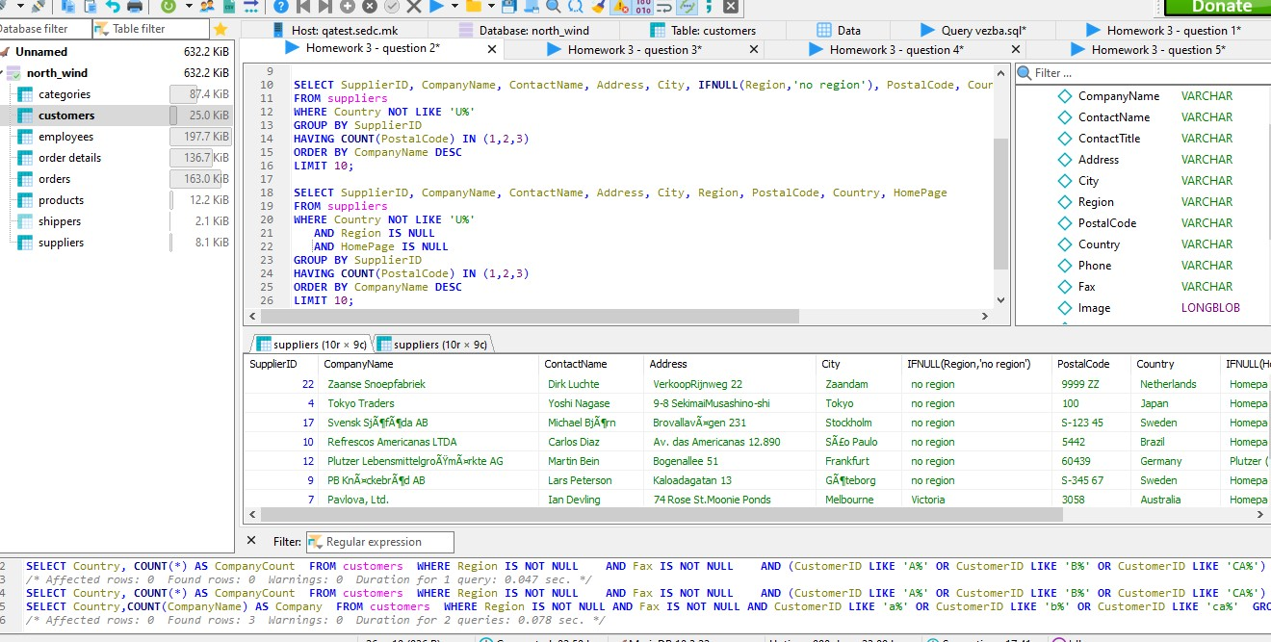

Zadaca 3 - prasanje 3

--We need **to** **count** **all** Orders **and** also make summation **of** their total unit price,

**where** they meet the **following** conditions:

⦁ There **is** discount

⦁ The ID **of** the product **is** **from** 3 **to** 9

⦁ There are **no** more **than** 30 pieces **in** stock

⦁ The ID **of** the orders **is** **from** 101** **to** 106\*\**--*

**SELECT** OrderID, ProductID, **SUM**(UnitPrice) **AS** TotalPrice, Quantity, Discount

**FROM** `order details`

**WHERE** Discount > 0

**AND** ProductID **BETWEEN** 3 **AND** 9

**AND** Quantity <= 30

**AND** OrderID **BETWEEN** 10100 **AND** 10699;

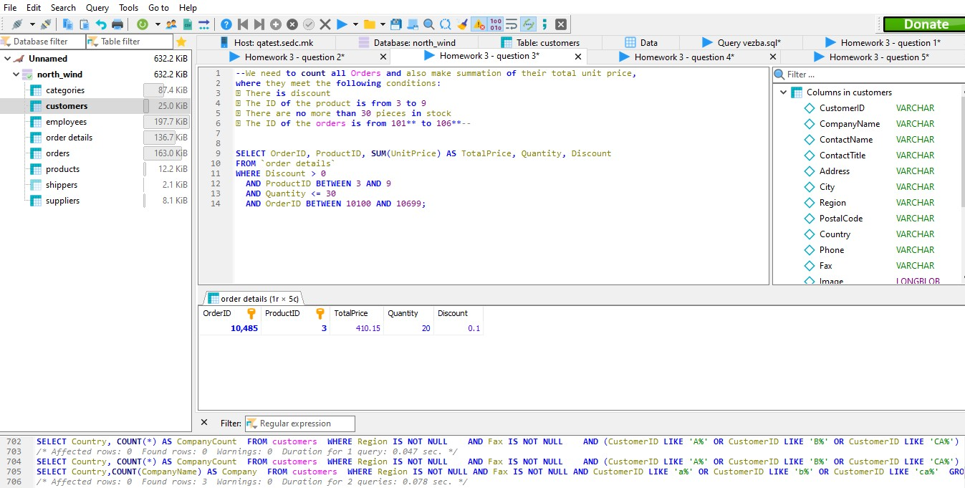

Zadaca 3 - prasanje 4

--We need **to** **list** **to** minimum **value**, the maximum **value** **and** the average **value** **of** Freight, **for** orders that fulfill the **following** conditions

⦁ **Date** **of** shipment **is** **between** 01.01.1994 **to** 01.01.1996

⦁ They are shipped via 1 **or** 2

⦁ There **is** **data** **in** Region*--*

**SELECT** ShippedDate, ShipVia, Freight, **MIN**(Freight) **AS** MinimumValue, **MAX**(Freight) **AS** MaximumValue, **AVG**(Freight) **AS** AverageValue, ShipRegion

**FROM** orders

**WHERE** ShippedDate **BETWEEN** '1994-01-01' **AND** '1996-01-01'

**AND** ShipVia **IN** (1, 2)

**AND** ShipRegion **IS** **NOT** **NULL**;

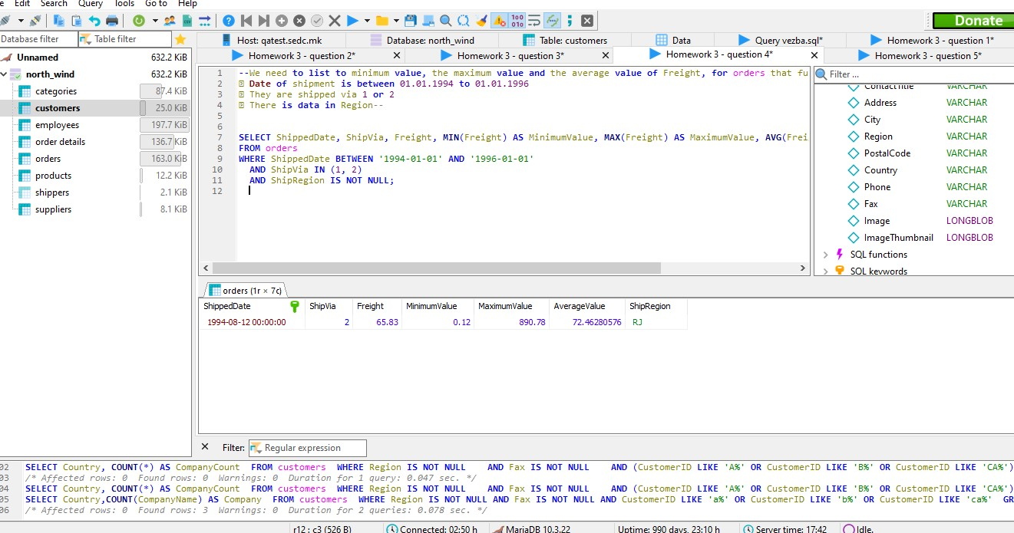

Zadaca 3 - prasanje 5

--**Write** a **query** **to** **return** the **number** **of** orders **for** **each** **order** **date** **in** the orders **TABLE**.*--*

**SELECT** OrderDate, **COUNT**(*) **as** Order_count

**FROM** orders

**GROUP** **BY** OrderDate;

